
Making Deal Sets for BBO Tournaments
Quick Start for experienced users - New Users see Next Page.
- Join the lin files together, either using an editor or click the button.
- Drag-and-drop the combined file onto an aaBridge open window.
Select and check & and check both and click
- Now drag-and-drop the new file into aaBridge, where you can Enter the Deal and use the DDS button and Analyser to determine the suitability of each hand. You can also “tweak” a hand by using the Edit & Hands buttons to drag cards from one hand to another to improve their playability.
- Remember clicking the Pencil Icon will open the file of hands in your text editor.
With the Force Saved Name check box checked, you can click the small Save button (top left in the green) and the pencil icon to quickly get to the text of the hand you have just edited. Then it is simple to cut and paste the contents of the md|| command from the newly saved file back to the main lin file containing your deals.
- Suggestion – In the text editor, add a short description to the board number header for a deal e.g. rh||ah|Board 7 6S lead d2 – HARD
\ extra hidden info added like this|
- You change the order of deals by cutting and pasting within your main lin file. When saved, aaBridge will display the deals in the new order.
- After a re-order and even at the start, you can check and click
Use the resulting lin file as your main file. Doing this means that you see the correct vulnerability for the way the deal WILL BE played.
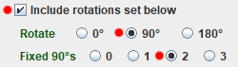
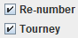
- Finally save the lin file in BBO Format. Check
and the settings as shown (red dots) & click The resulting file will have a name like origName___sn__90_rotation.lin

● You can use the button to save the deals into individual lin files. ●
New Users Start Here
The aaBridge document collection doc Lin Files - A Starter covers how lin files work and how to edit and use them (they are ordinary text files). You should be familiar with that document before reading this one.
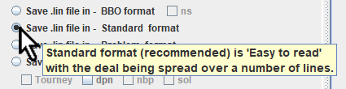
Pop Up Help
In aaBridge whenever you hover over a setting you often get a POP UP, use this as your HELP.
When a set of deals is presented in a BBO tournament they are automatically numbered starting from 1 (one). In addition, each deal is given the correct dealer and vulnerability for it’s duplicate board number. For example, the first board in your set will have North set as the dealer and both sides set non-vulnerable. Any board number, dealer or vulnerability that you have previously set is ignored.
Note - this does not happen with hands presented at a BBO teaching table or bidding practice table -- in those cases only the board number is changed.
Therefore, when producing a set of hands intended for use in a tournament it makes sense to pre-set the expected dealer and vulnerability for all the boards. This makes it easier to review the hands at a later date.
aaBridge now has the facility to allow you to do this easily, BUT it should be used only as the very last step in the production of your set of deals.
The remainder of this document is a suggestion of a workflow for producing such a set of deals. I hope you find it useful.

aaBridge as a source of hands
One source of hands is from aaBridge itself -- the aaBridge jar file. Windows users look in C:\ProgramSmall\aaBridge. Jar files are just zip files which have been renamed with a different extension. You can use your usual unzipping method to unzip the jar file. The many deals that you can find under Books-H (Historic) and Books-V are a good source of hands.
First Get the hands
I will assume that you have a collection of played hands as lin files (see Lin files - A Starter) – either your own hands or collected from elsewhere. In cases where the hands have been played, the first stage is to rotate them such that the declarer is South.
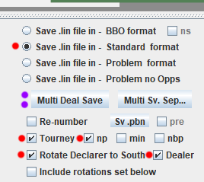
I prefer to work with the deals in Standard Format (first red dot) and only at the end convert them to BBO format for upload. You are free to work in BBO format if you wish.
Set all the checkmarks as shown in the diagram (red dots).
The most important options, Rotate Declarer to South and the Dealer checkbox, are what produces the saved deals with both declarer and dealer as South.
The Tourney checkbox causes the correct tournament vulnerability to be set on the board (with respect to position of the dealer). The np checkbox causes no players names to be saved AND stops the extra green lines (see below) from being saved.
Click the button (purple dots above).
When, as shown above, you are saving in standard format the hands will be saved into a lin file with the text __Std appended to the name. You can ‘drag and drop’ that file onto aaBridge. You can then use (click) the pencil icon to edit the file.
see - Quick Lin File Editing from inside aaBridge.doc
When you edit the Lin file (in a text editor like notepad++) individual deals may look something like
Suggestion - you can enter additional description using a ‘\’ back slash in the ah| command. The green text below is NOT shown to the user by aaBridge.
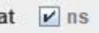 Stops the BLUE text being saved.
qx|7|
rh||ah|Board 7 6S lead d2 – HARD
\ such extra line(s) as these are kept
\ even when you save in BBO format. |
md|sAQJT...
If you need more information about using aaBridge features and buttons such as the
Enter the Deal
DDS
Analyser
see - Double Dummy Solver - DDS.doc
and the YouTube videos that you can access by clicking the YouTube link on the welcome page of aaBridge. Key videos include
009 - Using Shuf Op and the Analyser in aaBridge
008 - Edit, Play and Review in aaBridge
004 - Using the DDS analyser in aaBridge
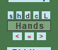
Note that when you are inside the deal you can use the Edit button and then the Hands button to allow you to drag and drop cards from one hand to another. The RED left and right arrows shown in the image on the right will rotate the hands, the equal sign between them will swap the two opponents hands. (Swapping over the ops hands and then rotating twice will produce a swap of the declarer and dummy’s hands).
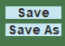
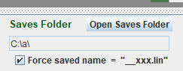
Suggestion - check the Force saved name = check box as shown on the right. This way whenever you use the Save button
the resulting edits to that deal will be saved in the file called __xxx.lin. This means the pencil icon will quickly open this small lin file in your editor and you can copy the changes into the main lin file you are preparing. When you save that file from within the editor, aaBridge will display the changes.
You can change the order of deals by cutting and pasting within your main lin file. As stated above when saved, aaBridge will display the deals in the new order.
After a re-order and even at the start, you can check the button and click
and use the resulting lin file as your main file. Doing this means that you see the correct vulnerability for the way the deal will be played when uploaded to BBO.

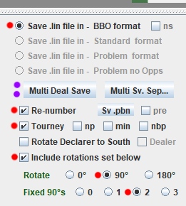
Finally
Save the lin file in BBO Format. Check the options as shown on the right (red dots).
Click
The resulting file will have a name like origName___sn__90_rotation.lin
The include rotation set below setting will first add 2 - 90° twists, which moves declarer and dealer from South to the North position for the first hand. Each successive deal will then get a 90° rotation so the declarer/dealer for the second hand will now be in the east position. This is the way you want the hand laid out for BBO tournaments.

Other Multi Deal Save Options
You can check the nbp checkbox that you can see on the same line as the
Tourney option. With this checked no bidding or play is saved with the hand.
To retain only the final contract and lead, you can check the min checkbox that you can see next to the nbp option. This retains only the contract bid by declarer, three passes, and the lead, in the resulting hand.
The ns checkbox that is placed just to the right of the BBO format option. This causes all additional spaces and blank lines to be removed from the lin file.

Alternative - Working with separate deals each in its own lin file
Once you have a set of deals “aligned” to South (dealer / declarer) you can use the
button to save the deals into individual lin files. The file can be re-ordered by renaming them and the set can be joined using the button.
<end document>

